**REPLACE THIS SENTENCE WITH THE TITLE OF YOUR ESSAY**

D.C. Rios (enter here your name) 1

1Major Specialization, Group Project #, include e-mail address, your TA name.

Replace these instructions with your text. The dimensions of your completed sheet should be no more than 6.5 inch (16.51 cm) wide by 9 inch (23 cm) long.

Please make sure your paper size is set to U.S. letter, 8.5" × 11", before submitting your file.

Page margins are set to be 1 inch on all sides.

PAGE 2 is reserved for your figure/pictures.

Create a **PDF file** (no larger than 3 MB).

We reserve the right to discard any image that is not legible or of poor quality.

The ENTIRE text/material must fit into the dimensions described above (this template reflects the correct format).

Digital Formats: Before submission your file MUST be converted to PDF.

Heading Styles: The section heads in this template use the recommended style (upper and lower case, bold, followed by a colon).

Automatic paragraph indents are imbedded to appear every time you use a hard return.

If you’re using the spell checker and it doesn’t seem to be working, check the “Language” option under the “Tools” to make sure that “No Proofing” isn’t selected as the default. You should also check that the default font is TIMES NEW ROMAN, 11pts, and you have 1.5 spacing paragraph.

All submissions WILL be checked with **Turnitin.** If need a green flag (<20%) to pass Turnitin test and submit your work. More than 20% will be considered PLAGIARISM!

Follow our instructions and guidelines!

**References:** If necessary, include references:

[1] Author A.B. and Author C.D. (2022) Journal of Planetary Research 1:11–54.

[2] Author E.F. et al. (2018) Planetary Science 5:74-84.

[3] Author G.H. (2021) NASA, Hyperlink.

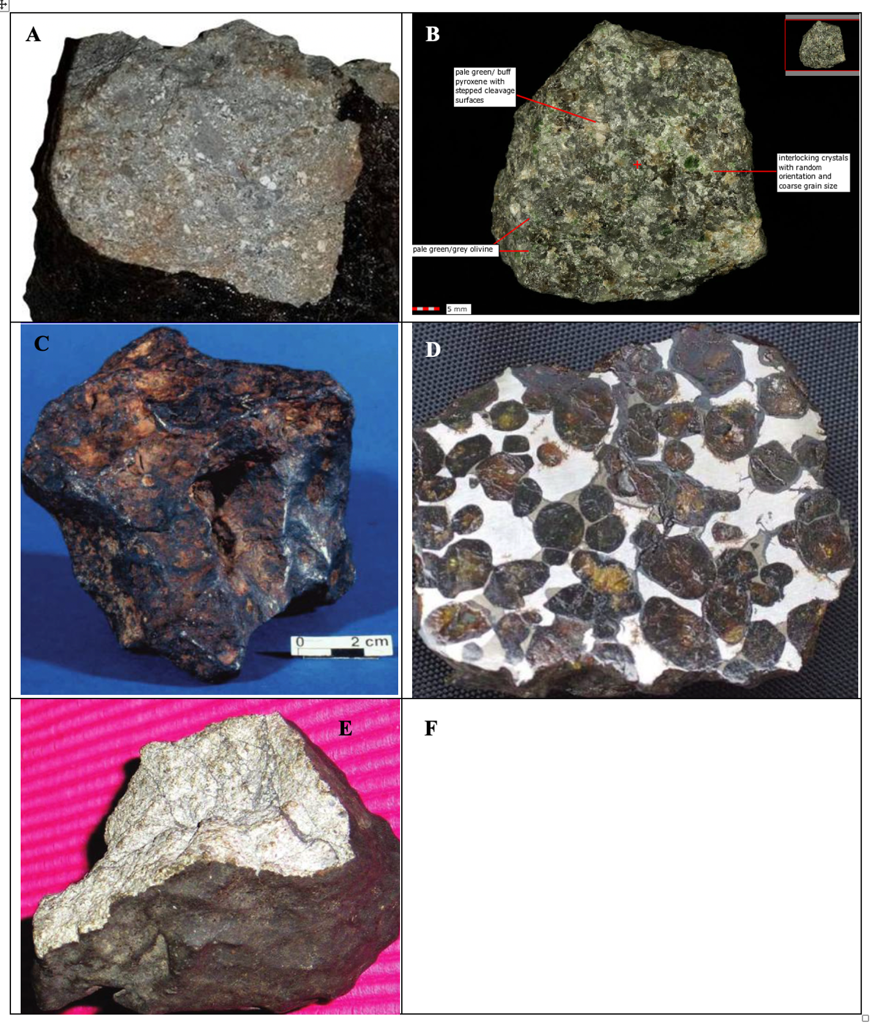**Figure.** [Page 2] Caption (Remember to clearly indicate each meteorite group and the meteorwrong. When possible, add the meteorite name. Pictures must be referenced on your essay. (A) caption (B) caption (C) caption (D) caption (E) caption (F) adds an image of your selected meteorite/caption.